PBCMT404: DATABASE SYSTEMS

MINI PROJECT REPORT

“Retail ecommerce Management System (REMS) using Python and MySQL”

(2025-2026 ACADEMIC YEAR)


B.Tech Semester IV

SREE BUDDHA COLLEGE OF ENGINEERING
(AUTONOMOUS)
PATTOOR P.O., NOORANAD , ALAPPUZHA , KERALA

DEPARTMENT OF
COMPUTER SCIENCE AND ENGINEERING (ARTIFICIAL INTELLIGENCE AND MACHINE LEARNING)
PREPARED BY
ABHIJITH A SHAJI SBC24AM003
ADITHYA PRAMOD SBC24AM009
JAMIYA MARIAM OMMEN SBC24AM037
PREM KRISHNAN SBC24AM045
RABI ATHUL BASWARIYYA SBC24AM046
SANIYA V SAM SBC24AM049

CONTENTS

CHAPTERS | CONTENTS | PAGE No
Chapter 1 | Introduction | 1
Chapter 2 | Methodology | 2-6
Chapter 3 | Implementation | 7-14
Chapter 4 | Results | 15-25
Chapter 5 | Conclusion | 26-27

CHAPTER - 1
INTRODUCTION
1.1 Overview of the System
The Retail eCommerce Management System (ReMS) is a database-driven application developed to facilitate online retail operations through an integrated digital platform. The system enables customers to browse products, manage shopping carts, and place orders, while administrators can efficiently manage inventory, users, and transactions.
The application is designed using Python (Tkinter) for the user interface and MySQL as the backend database, ensuring structured data management and a user-friendly experience. The system follows a relational database model, allowing efficient storage, retrieval, and manipulation of data.
1.2 Need for the System
Traditional retail systems often rely on manual processes or poorly structured data handling methods, which lead to issues such as data inconsistency, redundancy, and inefficiency in managing inventory and transactions. These systems lack real-time updates and are prone to human errors.
The Retail eCommerce Management System addresses these challenges by introducing an automated database system that ensures accurate data management, faster processing, and improved user experience. It provides a centralized platform for handling all retail operations efficiently and securely.
1.3 Objectives of the Project
The main objectives of the Retail eCommerce Management System are:
- To develop a structured and efficient database-driven retail system
- To implement user authentication and role-based access control
- To enable customers to browse products, add items to cart, and place orders
- To provide administrators with tools to manage products, users, and orders
- To ensure data integrity and consistency using relational database concepts
- To implement efficient data handling using SQL queries and transactions

CHAPTER – 2
METHODOLOGY
2.1 Requirement Analysis
The development of the Retail eCommerce Management System was based on a detailed analysis of user and system requirements derived from the Software Requirements Specification (SRS).
User Requirements (Customer)
- User registration and secure login
- Browsing products by category
- Searching and filtering products
- Adding products to shopping cart
- Placing orders and viewing order history
Admin Requirements
- Adding, updating, and deleting products
- Managing inventory and stock levels
- Viewing and updating customer orders
- Managing user accounts
- Monitoring system performance through dashboard analytics
System Requirements
- Secure data storage and retrieval using a relational database
- Fast query execution for real-time operations
- Transaction handling for consistency during order processing
- Role-based access control for Admin and Customer
2.2 System Design
The system is designed using the Relational Database Model, ensuring structured data organization and efficient relationships between entities.
Entities Identified
- Users – stores customer and admin details
- Products – stores product information
- Orders – stores order details
- Order_Items – stores product details within each order
Relationships
- One user can place multiple orders (1:N relationship)
- One order can contain multiple products (1:N relationship)
- Products and orders are linked through the Order_Items table (Many-to-Many resolved)
This design ensures data normalization, reduces redundancy, and maintains referential integrity using primary and foreign keys. The ER DIAGRAM of the system is shown below.
Design Considerations
- The database design follows normalization principles to eliminate redundancy and improve data consistency.
- Primary keys are used to uniquely identify each record within a table.
- Foreign keys are implemented to establish relationships between tables and ensure referential integrity, preventing invalid or orphan records.
- Constraints such as NOT NULL, UNIQUE, and CHECK are used to maintain data integrity by enforcing valid and consistent data entries.
- The system is designed to support scalability and efficient data operations for handling large volumes of transactions.
2.3 ER Diagram
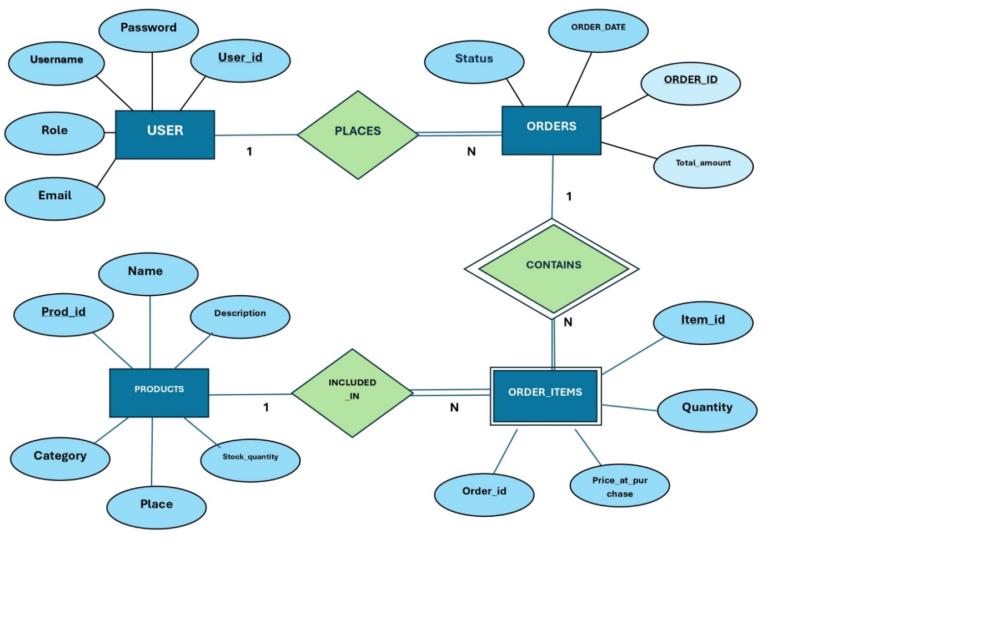
Figure 2.1 – ER diagram

2.3 System Architecture
The system follows a Two-Tier Architecture, consisting of:
1. Presentation Layer (Frontend)
- Developed using Python Tkinter
- Provides graphical user interface for interaction
- Handles user inputs such as login, product selection, and order placement
2. Data Layer (Backend)
- Implemented using MySQL database
- Stores all persistent data including users, products, and orders
- Executes SQL queries for data manipulation
The frontend communicates with the backend using mysql-connector-python, ensuring seamless interaction between the application and database.
2.4 Tools and Technologies Used
The system is implemented using the following technologies:
- Programming Language: Python
- Frontend: Tkinter (GUI-based interface)
- Database: MySQL
- Database Connector: mysql-connector-python
- Security: SHA-256 hashing for password protection

2.5 Development Approach
The system was developed using a modular approach, where each functionality is implemented as a separate module. This improves code readability, maintainability, and scalability.
Key modules include:
- Authentication module (Login/Register)
- Product management module
- Cart and order processing module
- Admin dashboard module
The system was incrementally developed and tested to ensure correctness and reliability.

CHAPTER - 3
IMPLEMENTATION
3.1 Database Implementation (MySQL)
The database for the Retail eCommerce Management System was implemented using MySQL following the relational database model. The design includes well-structured tables with primary keys and foreign keys to ensure data integrity, consistency, and normalization.
Database Creation
CREATE DATABASE IF NOT EXISTS ReMS_DB;
USE ReMS_DB;
This initializes the database used for storing all system data.
Users Table
CREATE TABLE Users (
user_id INT AUTO_INCREMENT PRIMARY KEY,
username VARCHAR(50) NOT NULL UNIQUE,
email VARCHAR(100) NOT NULL UNIQUE,
password_hash VARCHAR(255) NOT NULL,
role ENUM('Admin','Customer') DEFAULT 'Customer',
created_at TIMESTAMP DEFAULT CURRENT_TIMESTAMP);
The Users table stores login credentials and roles. Unique constraints prevent duplicate accounts, ensuring data consistency.

Products Table
CREATE TABLE Products (
prod_id INT AUTO_INCREMENT PRIMARY KEY,
name VARCHAR(100) NOT NULL,
description TEXT,
price DECIMAL(10,2) NOT NULL CHECK (price >= 0),
stock_qty INT NOT NULL DEFAULT 0,
category VARCHAR(50));
This table stores product details. The CHECK constraint ensures valid pricing, maintaining domain integrity.
Orders Table
CREATE TABLE Orders (
order_id INT AUTO_INCREMENT PRIMARY KEY,
user_id INT,
order_date TIMESTAMP DEFAULT CURRENT_TIMESTAMP,
total_amount DECIMAL(10,2),
status ENUM('Pending','Shipped','Delivered','Cancelled') DEFAULT 'Pending',
FOREIGN KEY (user_id) REFERENCES Users(user_id) ON DELETE CASCADE);
The Orders table records each transaction. The foreign key ensures referential integrity by linking orders to valid users.
Order_Items Table
CREATE TABLE Order_Items (
item_id INT AUTO_INCREMENT PRIMARY KEY,
order_id INT,
prod_id INT,
quantity INT NOT NULL,
price_at_purchase DECIMAL(10,2),
FOREIGN KEY (order_id) REFERENCES Orders(order_id) ON DELETE CASCADE,
FOREIGN KEY (prod_id) REFERENCES Products(prod_id) ON DELETE SET NULL);
This table resolves the many-to-many relationship between orders and products, ensuring proper normalization.
3.2 Database Connection (Python)
The system connects to the MySQL database using the mysql-connector-python library.
import mysql.connector
def get_db():
conn = mysql.connector.connect(
host="localhost",
user="root",
password="your_password",
database="ReMS_DB",
autocommit=False )
return conn
This function establishes a connection between the application and database. Autocommit is disabled to allow controlled transaction handling.
3.3 User Authentication Module
User authentication is implemented securely using password hashing to prevent storing plain-text passwords.
Password Hashing
import hashlib
def hash_password(plain):
return hashlib.sha256(plain.encode()).hexdigest()
Hashing ensures security by converting passwords into irreversible encrypted form.
User Registration
cur.execute(
"INSERT INTO Users (username,email,password_hash) VALUES (%s,%s,%s)",
(username, email, hash_password(password)))
conn.commit()
New users are stored securely in the database while enforcing uniqueness constraints.
User Login
cur.execute("SELECT * FROM Users WHERE username=%s", (username,))
user = cur.fetchone()
if user and user["password_hash"] == hash_password(password):
return user
This verifies user credentials by comparing hashed passwords, ensuring secure authentication.
3.4 Product Management Module
This module handles product-related operations such as viewing, adding, and updating inventory.
Fetch Products
cur.execute("SELECT * FROM Products")
products = cur.fetchall()
Retrieves product data efficiently using SQL queries.
Add Product
cur.execute(
"INSERT INTO Products (name,description,price,stock_qty,category) VALUES (%s,%s,%s,%s,%s)",
(name, desc, price, stock, category))
Allows administrators to insert new products into the system.
Update Product
cur.execute(
"UPDATE Products SET name=%s, price=%s, stock_qty=%s WHERE prod_id=%s",
(name, price, stock, prod_id))
Enables real-time inventory updates, ensuring data accuracy.

3.5 Order Processing Module
This module manages order creation and maintains relationships between users, orders, and products.
Insert Order
cur.execute(
"INSERT INTO Orders (user_id,total_amount,status) VALUES (%s,%s,%s)",
(user_id, total, "Pending"))
order_id = cur.lastrowid
Each order is uniquely stored and linked to a user.
Insert Order Items
cur.execute(
"INSERT INTO Order_Items (order_id,prod_id,quantity,price_at_purchase) VALUES (%s,%s,%s,%s)",
(order_id, prod_id, qty, price))
Stores detailed product-level information for each order.
3.6 Transaction Handling (Commit & Rollback)
Transactions are used to maintain consistency during order processing.
try:
conn.start_transaction()
# Perform order and stock operations
conn.commit()
except:
conn.rollback()
This ensures atomicity — either all operations are completed successfully or none are applied, preventing partial updates.
3.7 Concurrency Control and Stock Management
To prevent issues like overselling, row-level locking is implemented.
cur.execute(
"SELECT stock_qty FROM Products WHERE prod_id=%s FOR UPDATE",
(prod_id,))
The FOR UPDATE clause locks the selected rows, ensuring safe concurrent transactions and maintaining consistency.
3.8 GUI Implementation (Tkinter)
The graphical user interface is implemented using Python Tkinter, providing an interactive environment for users.
Main Window Setup
import tkinter as tk
root = tk.Tk()
root.title("ReMS")
root.geometry("1100x700")
Button Example
login_btn = tk.Button(root, text="Login", command=login_user)
login_btn.pack()

Displaying Data (Treeview)
from tkinter import ttk
tree = ttk.Treeview(root)
tree["columns"] = ("Product ID", "Name", "Price")
tree.heading("Product ID", text="ID")
tree.heading("Name", text="Name")
tree.heading("Price", text="Price")
tree.pack()
The GUI enables user interaction and displays database data dynamically.
3.9 System Workflow
The system follows a structured flow:
- User registers and logs into the system
- Products are fetched from the database and displayed
- User adds products to cart
- During checkout, stock is validated and locked
- Order and order items are stored in the database
- Transaction is committed, and stock is updated
This workflow ensures smooth operation and proper interaction between frontend and database.

CHAPTER - 4
RESULTS
4.1 User Authentication (Login and Registration)
The system provides secure user authentication through login and registration functionalities.
- The registration page allows new users to create accounts with unique usernames and email IDs.
- Passwords are securely stored using hashing techniques, ensuring data security.
- The login system verifies user credentials and grants access based on user roles (Admin or Customer).
📌 Login Page :
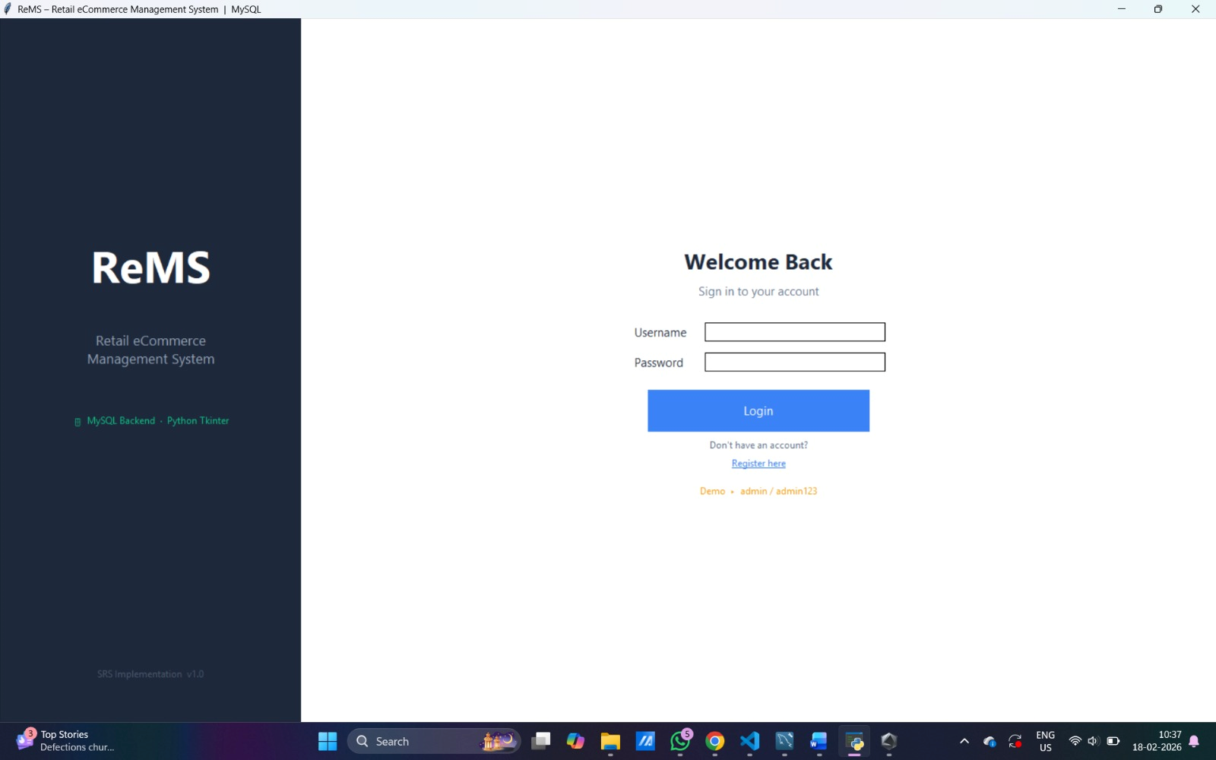
Figure 4.1 : Login Page

📌 Registration Page :
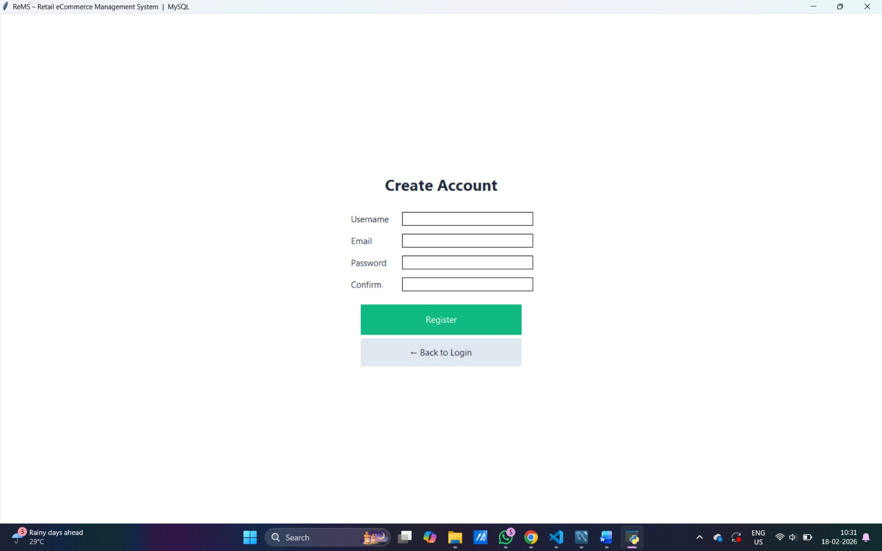
Figure 4.2: Registration Page
Result:
The authentication system successfully validates users and prevents unauthorized access, ensuring secure entry into the system.
4.2 Product Browsing and Shopping Cart
The system allows customers to browse available products and manage their shopping cart.
- Products are displayed with details such as name, price, category, and stock availability.
- Users can search and filter products for easy navigation.
- Items can be added to the cart, where quantity and total cost are dynamically updated.

📌 Product Listing Page and Shopping Cart Page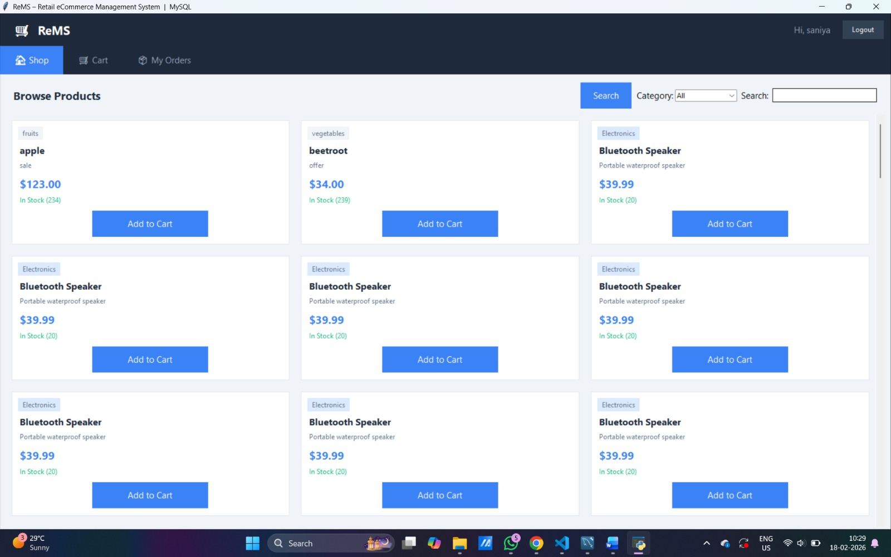
Figure 4.3: Dashboard
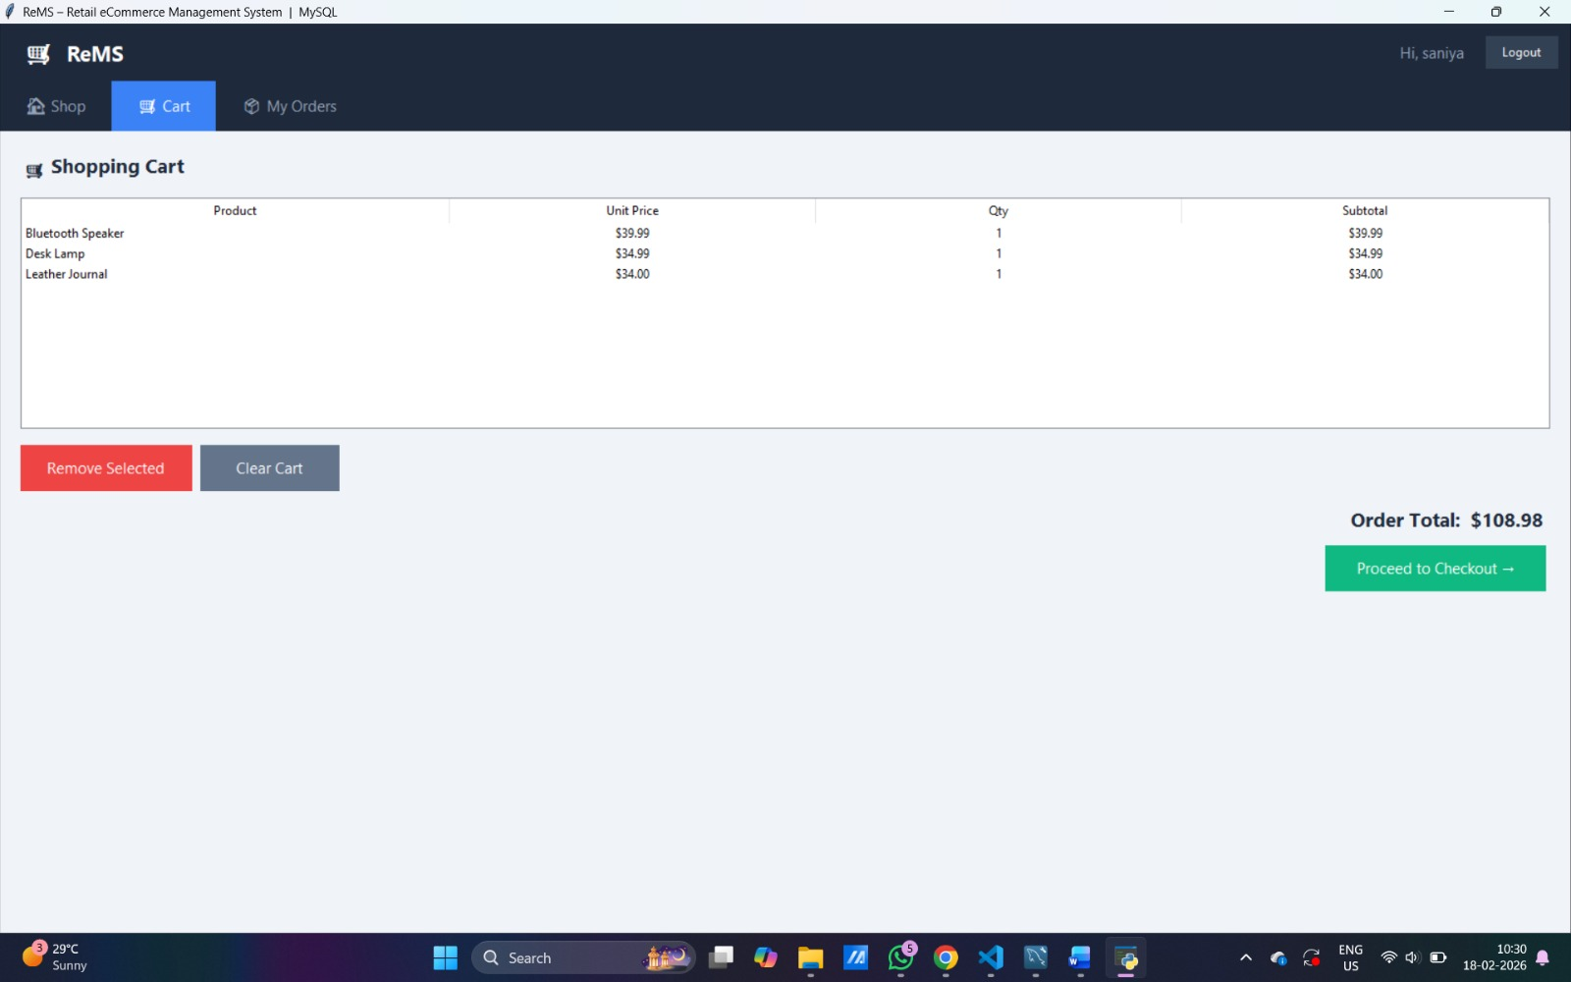
Figure 4.4 : Shopping cart page
Result:
The system efficiently retrieves product data from the database and allows users to interact with it in real time.
4.3 Order Processing
The system enables users to place orders through a structured checkout process.
- During checkout, product stock is verified before confirming the order.
- Orders and corresponding order items are stored in the database.
- The system updates inventory automatically after successful order placement.
📌 Checkout Page :
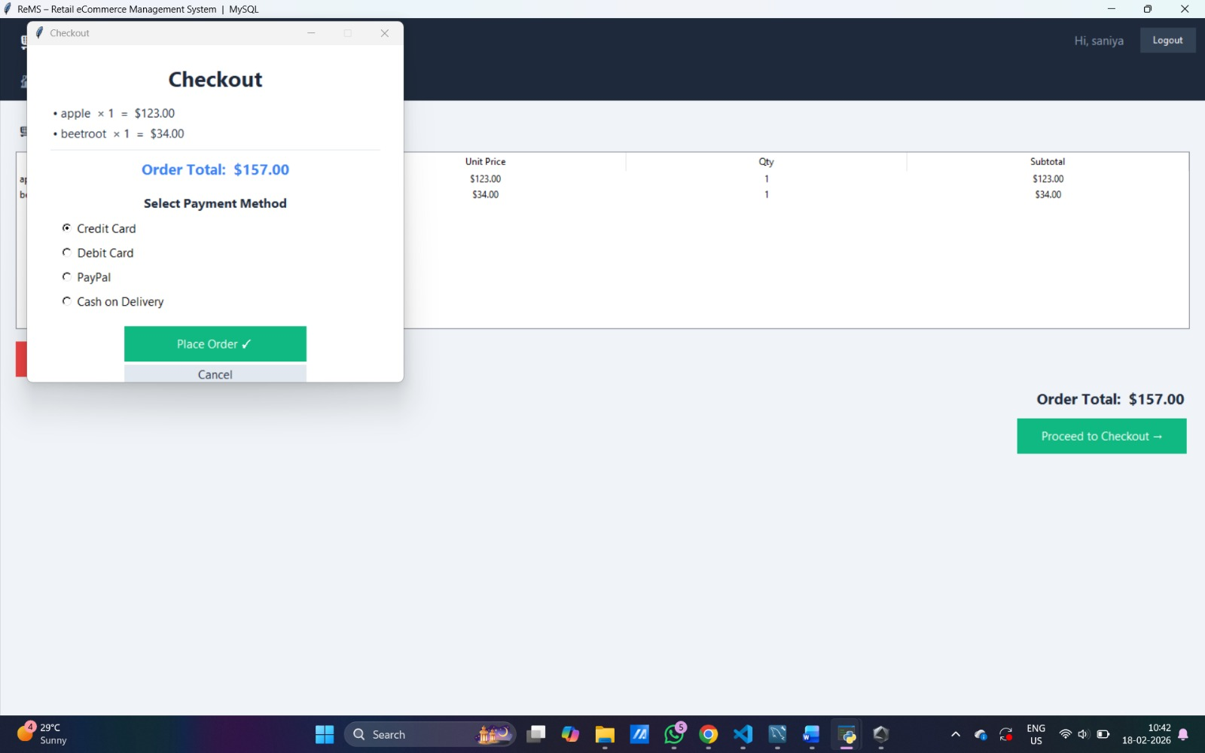
Figure 4.5 : Checkout page

📌 Order Confirmation :
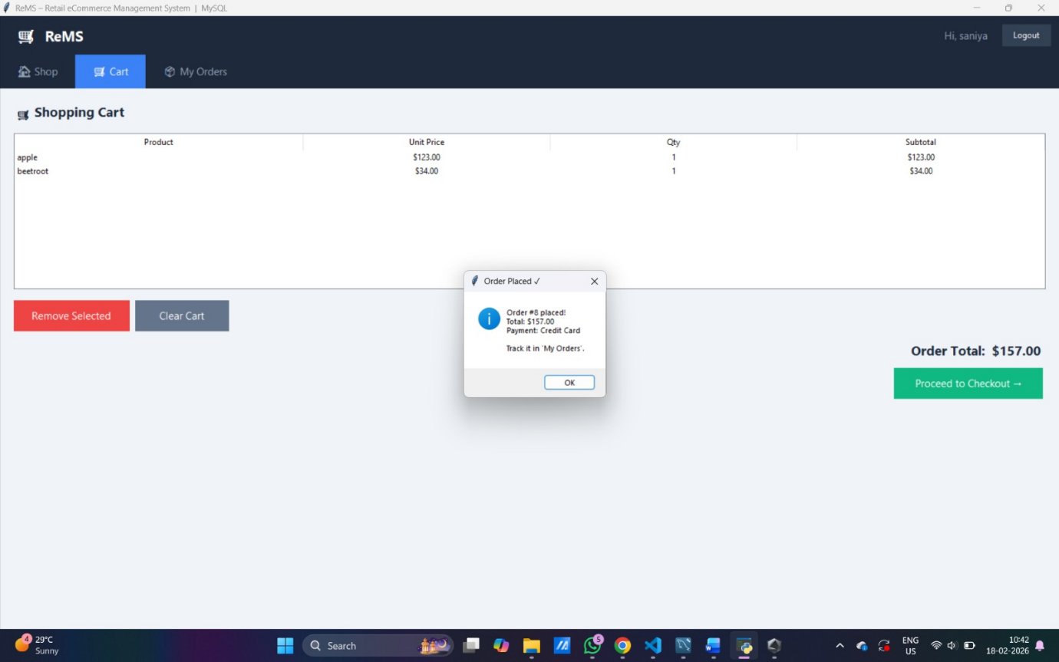
Figure 4.6 : Order Confirmation

Result:
Orders are processed accurately, and all related data is stored consistently in the database.
4.4 Customer Order History
The system provides a feature for customers to view their past orders.
- Users can track order details such as products purchased, quantity, and order status.
- Orders are displayed in descending order based on date.

📌 Order History Page :
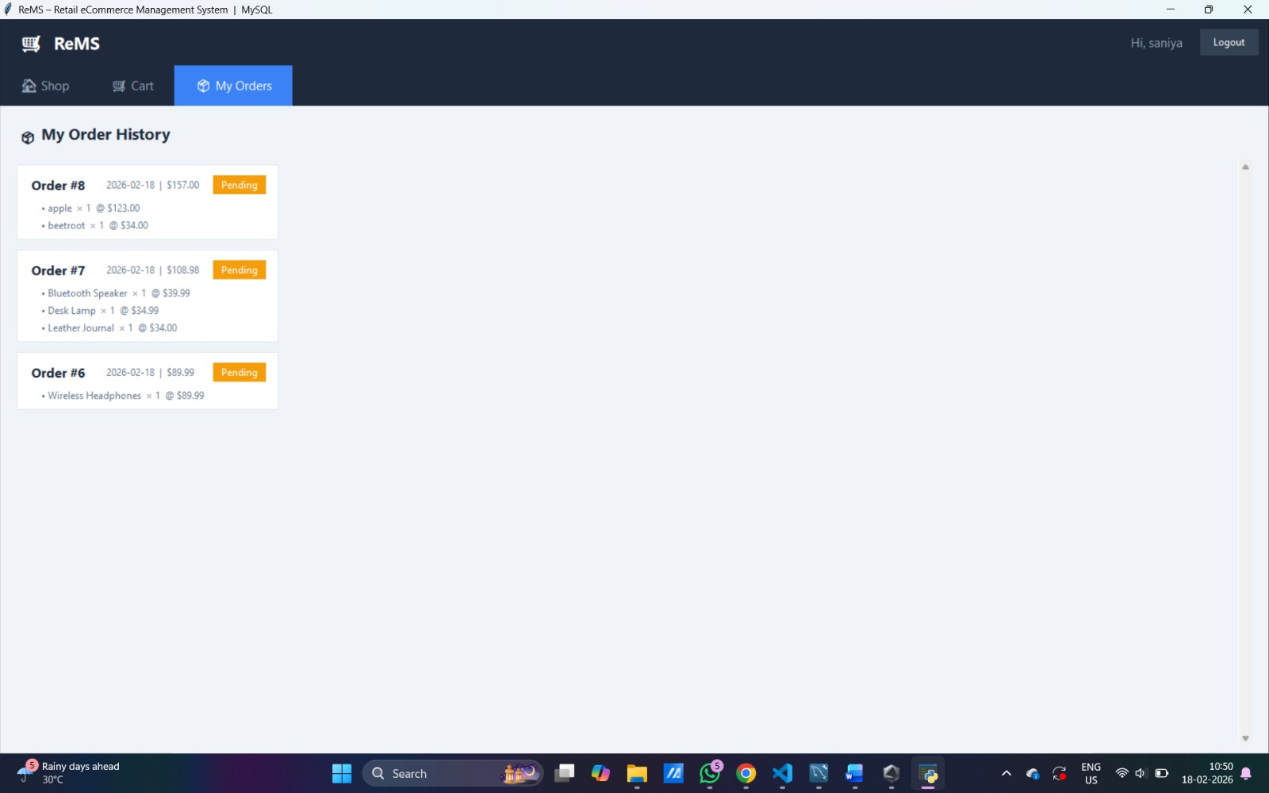
Figure 4.7: Order History Page

Result:
The system successfully maintains and retrieves historical transaction data for users.
4.5 Admin Dashboard
The admin panel provides an overview of system performance and key metrics.
- Displays total revenue, number of orders, users, and products.
- Provides real-time insights into system activity.
- Helps administrators monitor business performance effectively.

📌 Admin Dashboard :
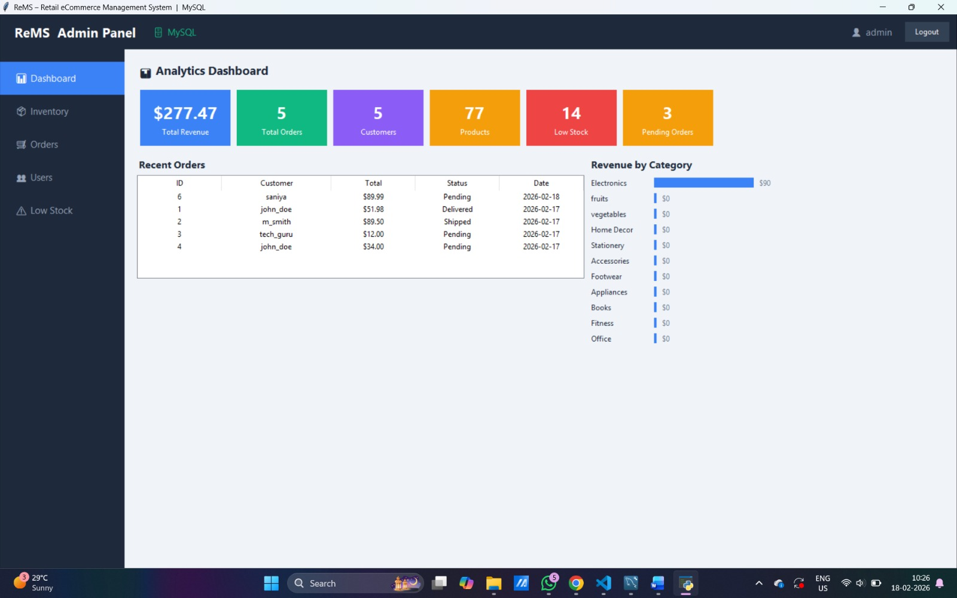
Figure 4.8 : Admin Dashboard

Result:
The dashboard aggregates data efficiently using SQL queries, enabling quick decision-making.
4.6 Inventory and Order Management
The system provides complete control over products and orders for administrators.
- Admin can add, update, and delete products.
- Stock levels are updated automatically after each order.
- Orders can be managed and their status updated (Pending, Shipped, Delivered, Cancelled).

📌 Inventory and Order Management :
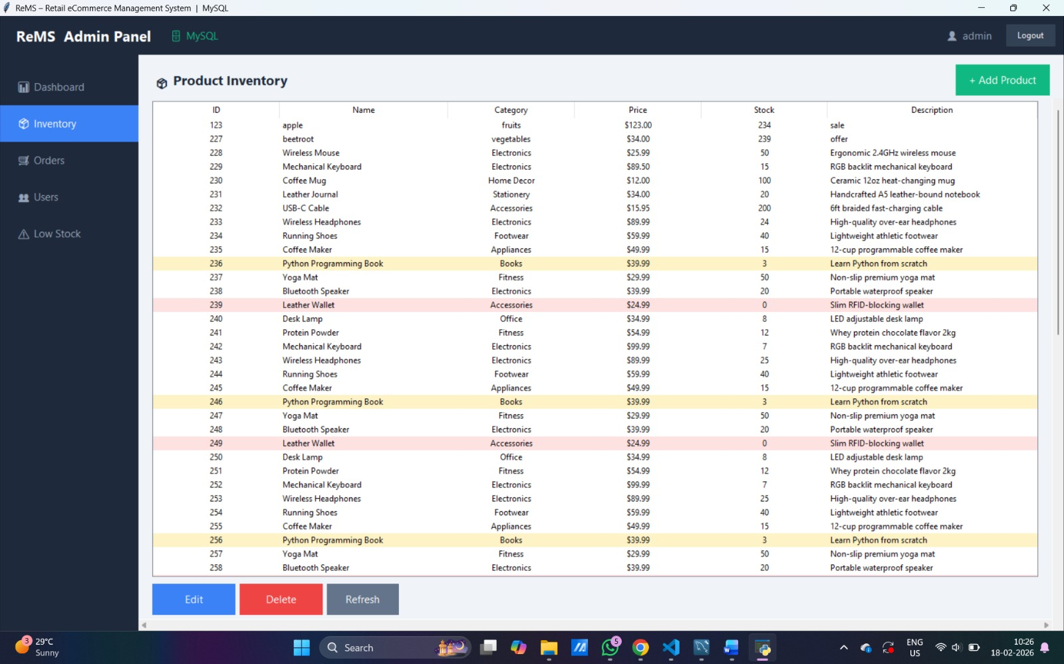
Figure 4.9 : Admin Product Inventory
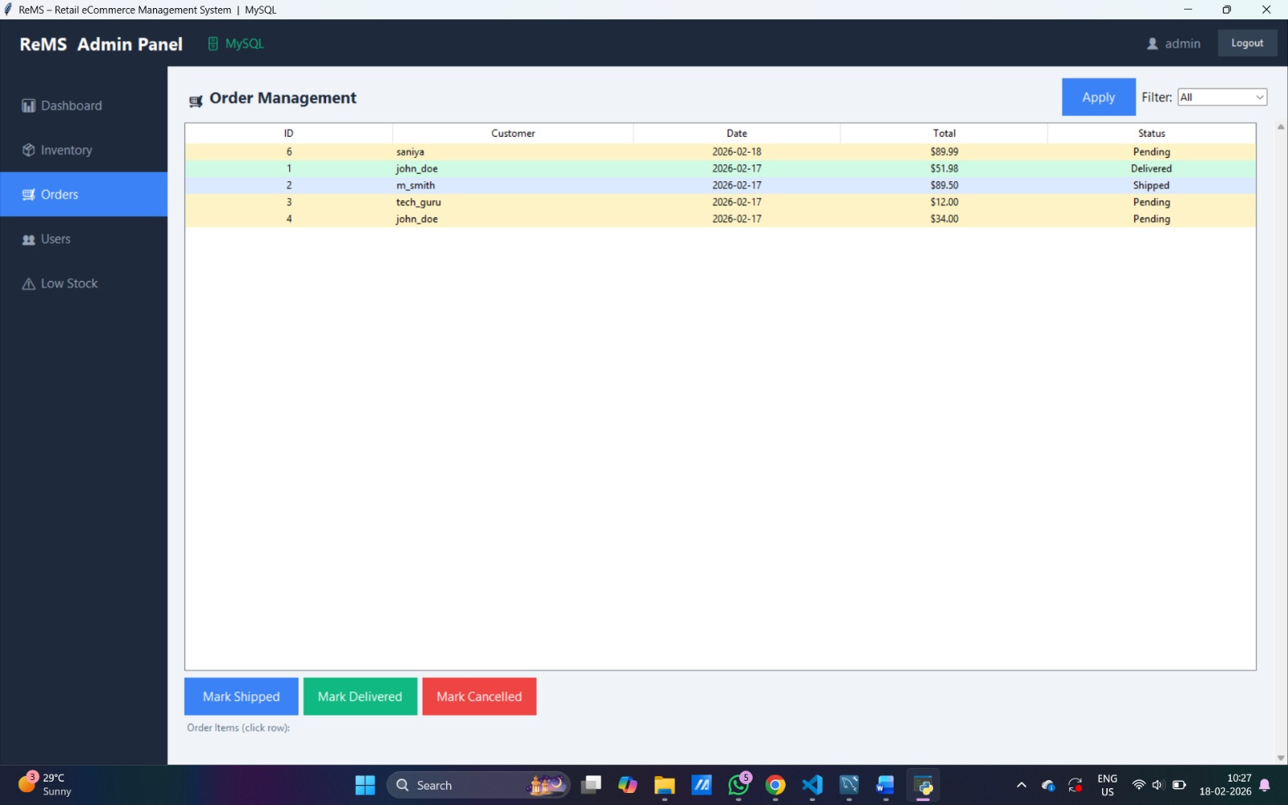
Figure 4.10 : Order management
Result: The system ensures accurate inventory tracking and effective order management.
4.7 User Management System
The system provides a dedicated user management module for administrators to control user accounts and roles.
- The admin can view all registered users along with their details such as username, email, role, and account creation date.
- The system allows role switching between Customer and Admin, enabling flexible access control.
- Administrators can delete user accounts when necessary, ensuring proper system maintenance.
- The system prevents critical actions such as modifying or deleting the currently logged-in admin, ensuring system safety.
📌 User Management Page :
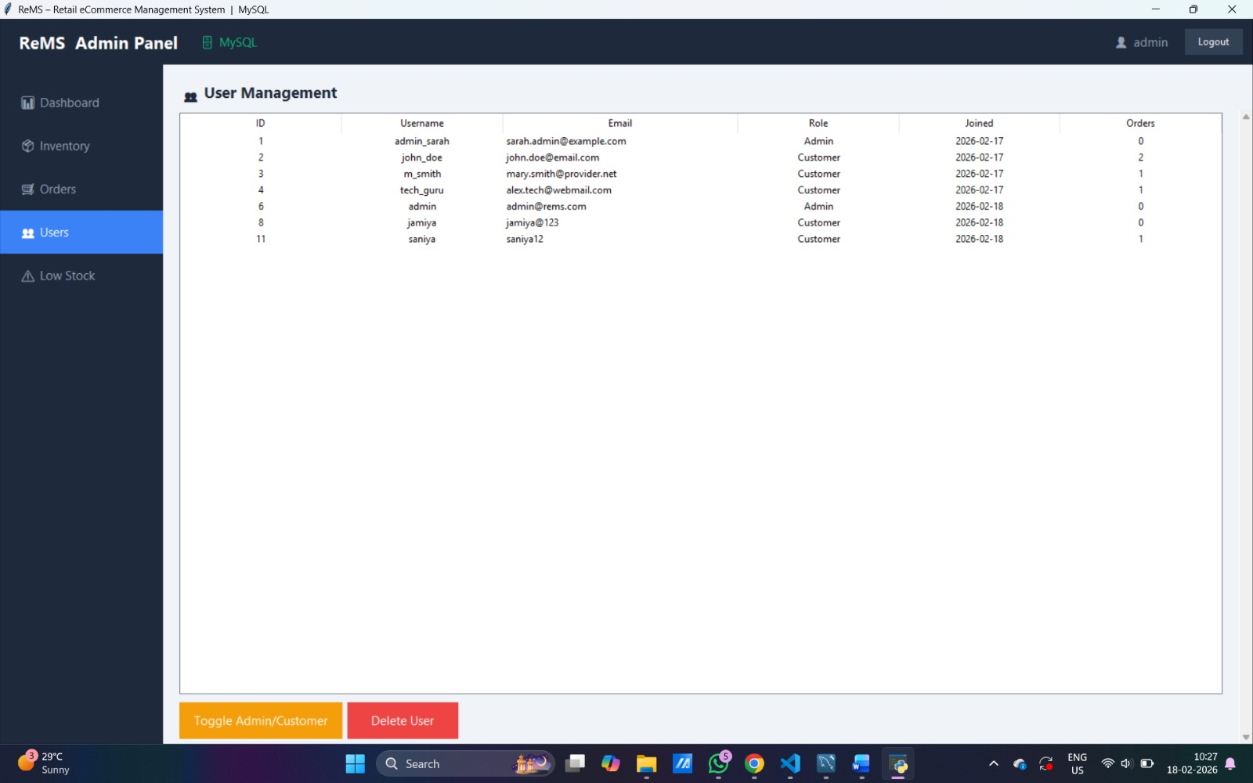
Figure 4.11 : User Management
Result:
The user management module ensures efficient handling of user accounts and enforces role-based access control, improving system security and administration.
4.8 Low Stock Alert System
The system includes a low stock monitoring feature to help administrators maintain inventory levels effectively.
- Products with stock below a defined threshold are automatically identified.
- The system highlights low-stock and out-of-stock items visually.
- Administrators can restock products directly from the interface.
- This feature ensures that inventory shortages are detected early and handled efficiently.
📌 Low Stock Alert Page :
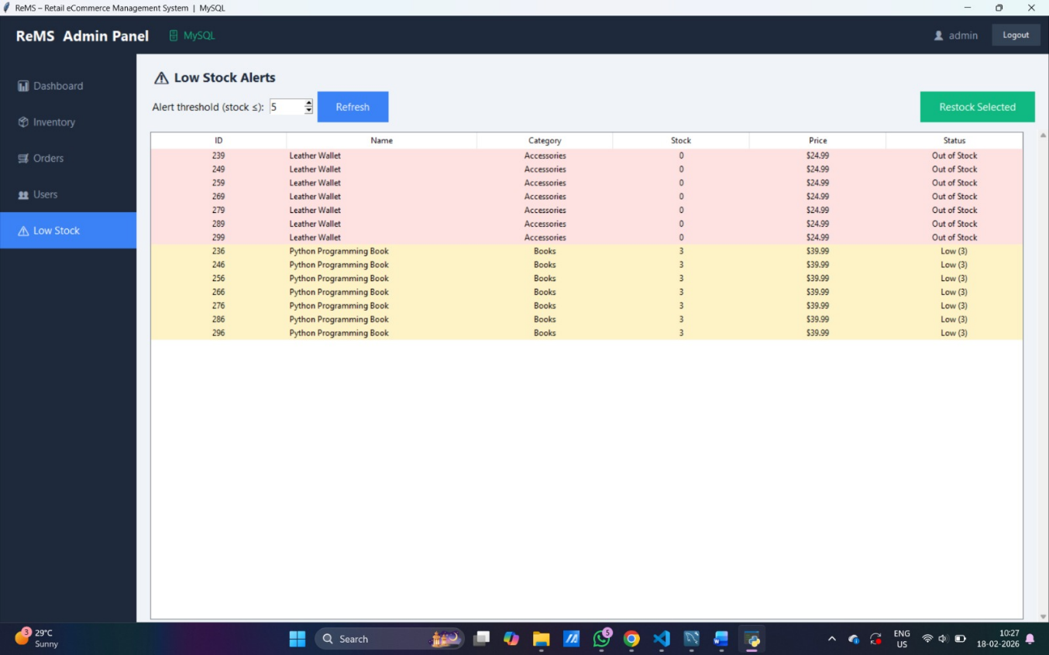
Figure 4.12 : Low Stock Alert Page
Result:
The low stock alert system enables proactive inventory management and prevents product unavailability, improving overall system efficiency.
4.7 System Validation and Data Integrity
The system ensures reliable and consistent database operations through various mechanisms:
- Transaction Handling:
Ensures atomic operations using commit and rollback mechanisms.
- Concurrency Control:
Row-level locking (FOR UPDATE) prevents multiple users from modifying the same data simultaneously, avoiding overselling.
- Data Integrity:
Foreign keys and constraints maintain valid relationships between tables.
- Error Handling:
The system prevents invalid operations such as placing orders with insufficient stock.
Result:
The system maintains high reliability, consistency, and correctness in all operations.

CHAPTER - 5
CONCLUSION
5.1 Conclusion
The Retail eCommerce Management System (ReMS) was successfully designed and implemented using Python and MySQL, providing a structured and efficient platform for managing online retail operations. The system demonstrates the effective use of relational database concepts such as normalization, primary and foreign keys, and data integrity constraints.
The application supports essential functionalities including user authentication, product management, shopping cart operations, and order processing. Additionally, administrative features such as inventory management, user control, and low stock monitoring enhance the overall efficiency of the system.
The use of transaction handling ensures data consistency and reliability during critical operations like order placement, while concurrency control mechanisms prevent issues such as overselling. Overall, the system achieves its objective of providing a reliable, secure, and scalable solution for retail management.
5.2 Learning Outcomes
Through the development of this project, the following concepts were understood and applied:
- Practical implementation of relational database design
- Use of SQL for data manipulation and querying
- Implementation of primary keys, foreign keys, and constraints
- Understanding of transaction management (commit and rollback)
- Application of concurrency control techniques
- Integration of frontend (Tkinter) with backend database (MySQL)
- Development of a modular and scalable application
5.3 Future Enhancements
The system can be further improved by adding advanced features such as:
- Integration of online payment gateways
- Development of a web-based or mobile application interface
- Implementation of real-time order tracking
- Addition of graphical analytics and reporting tools
- Enhancement of security using advanced encryption techniques
- Integration of recommendation systems using machine learning

